**Programare Avansata pe Obiecte  
Laborator 1**

**Pahontu Bogdan-Ionut**

**E-mail:** [**pahontubogdan@gmail.com**](mailto:pahontubogdan@gmail.com)

Contents

1. Understanding the Java Class Structure 3

1.1. Fields and methods 3

1.2. Ordering Elements in a class 4

1.3. Comments 4

1.4. Classes VS Files 5

1.5. JVM; JDK; JRE 5

2. Understanding Package (Declarations and Imports) 6

2.1. Importing packages 6

3. Object References and Primitives 8

3.1. Primitive types 8

3.2. Reference types 10

3.3. Differences between primitives and reference types 11

4. Declaring and initializing variables 11

5. Operators 12

6. If-Then Statement 13

7. Switch Statement 13

8. While / Do while 14

9. Break / Continue 15

10. Scanner Class 16

# Understanding the Java Class Structure

## Fields and methods

* Java classes have two primary **elements**:
  + **Methods:** operate on the state of the program
  + **Fields** (variables): hold the state of the program
* Together they are called the **members of the class.**
* The full declaration of a method is called a ***method signature****.*

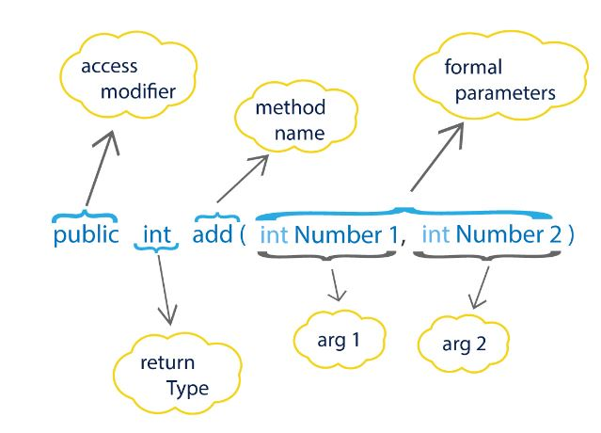

Figure 1 - Method Signature

**Example**:

**package** examples;  
  
**public class** A_MethodSignature {  
 **public static void** main(String[] args){  
 System.***out***.println(**"Hello world !"**);  
 }  
}

}

**Task 1**:

1. Create packages lab1 🡪 tasks 🡪task1.
2. Create a class with two methods:
   1. Public static void main method;
   2. One method that is public and returns the sum of two integer numbers;

## Ordering Elements in a class

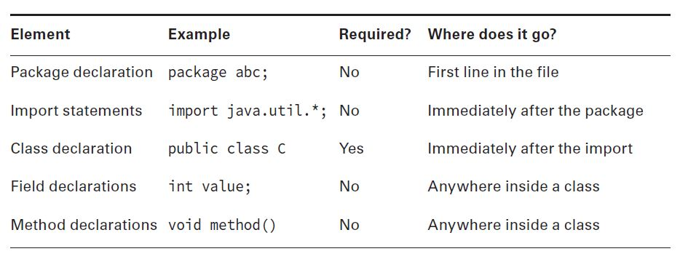 Figure 2 – Elements order

## Comments

* Comments aren’t executable code.
* Comments make your code easier to read.
* There are three types of comments in Java:
  + Single-line comment: // comment until end of line
  + Multiple-line comment:

/* Multiple

line comment

*/

* + Javadoc comment:

/**

* Javadoc multiple-line comment

* @author John

*/

## Classes VS Files

* Most of the time, each Java class is defined in its own *.java file.
* You can even put two classes in the same file. When you do so, at most one of the classes in the file is allowed to be public.

**public class** C_PublicClass {  
 **public static void** main(String args[]){  
 System.***out***.println(**"This is the main method of the public class"**);  
 AnotherClass.*anotherMethod*();  
 }  
}  
  
**class** AnotherClass{  
 **public static void** anotherMethod(){  
 System.***out***.println(**"Hello from AnotherClass"**);  
 }  
}  
  
*/*public class ThirdClass{  
 // This will generate a compiling error  
}*/*

* If you do have a public class, **it needs to match the file name**.
* Public class ThirdClass would not compile in a file named C_PublicClass.java.

## JVM; JDK; JRE

* **JDK** – used for development and compiling the applications.
* Contains JRE and development tools:
  + Compiler (javac.exe) - converts java code into bytecode.
  + Java application launcher (java.exe) – loads the class and invokes its main method.
* **JRE** – used for running the application. Contains JVM, class libraries (like util, math,lang, awt, swing, etc) and other supporting files

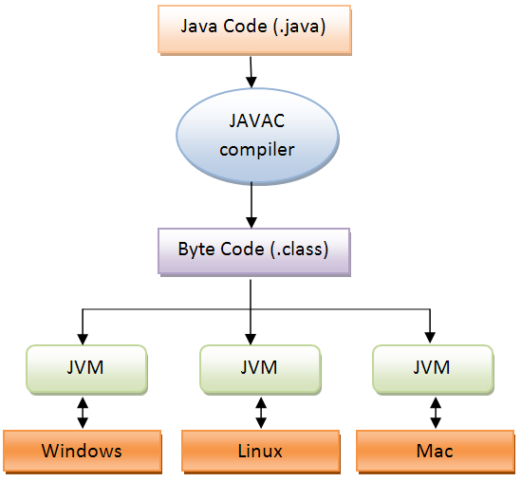

Figure 3 – JVM, JDK, JRE

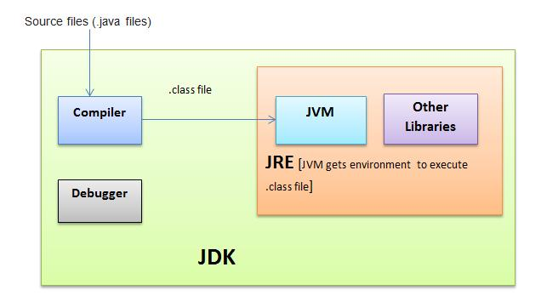

Figure 4 – JVM, JDK, JRE

# Understanding Package (Declarations and Imports)

## Importing packages

* In java we use packages to organize our classes and interfaces.
* Import tells the compiler which package to look in to find a class (ex. ImportExample class).
* **Wildcards:** **\*** is the wildcard that matches all the classes in the package.
  + Imports only classes (not methods, child packages, fields)
* Redundant imports:
  + The java.lang package is automatically imported.
  + To import classes in the same package.
* We want to import the class named Path. This can be found in the package java.nio.file.Path.

import java.nio.*; // NO GOOD – a wildcard only matches class names, not child packages.

import java.nio.*.*; // NO GOOD – you can only have one wildcard and it must be at the end.

import java.nio.file.Path.*; // NO GOOD – you cannot import methods, only class names.

* **Naming conflicts:** we use packages so that a class names doesn’t have to be unique across all of Java.

Example: Conflicts class (java.util.Date and java.sql.Date)

* **The first explicit import takes precedence over the second. (example: Conflicts class)**

import java.util.Date;

import java.sql.Date; --Error: *The import java.sql.Date collides with another import statement.*

**Task 2**:

1. Create packages lab1 🡪 tasks 🡪task2.
2. Create class Zoo with main method in task2 package.
3. Compile and run class Zoo.
4. Create class ZooArguments in task2 package.
5. Compile and run ZooArguments with 2 arguments, 1 argument and three arguments.

Obs:

**javac package/*.java –** compile everything in a package

In order to compile from command line please follow these commands:

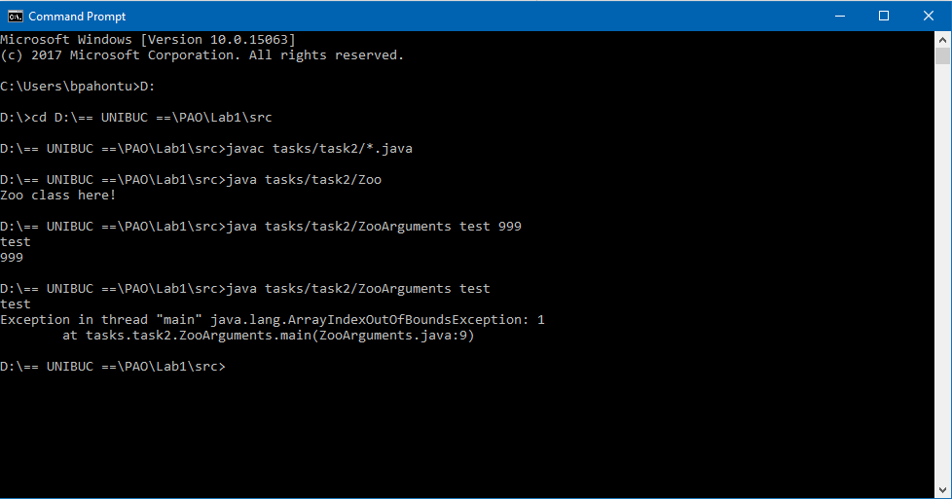

Figure 5 – Compile/Run program

**Task 3**:

1. Create package task3 into tasks package with two sub-packages: packagea and packageb
2. Each package will contain a Main class that will have one single public static void method named “**showPackage**”. Method will return the package name.
3. Create a new package named mainpackage into tasks/ task3
4. Create a Main class with a public static void main function that calls showPackage from packagea and then showPackage from packageb

# Object References and Primitives

## Primitive types

|  |  |  |  |  |
| --- | --- | --- | --- | --- |
| **Keyword** | **Type** | **Minimum Range** | **Maximum Range** | **Example** |
| boolean | true or false | n/a | n/a | true |
| byte | 8-bit integral value | - $2^{7}$ (-128) | $2^{7}$-1 (127) | 123 |
| short | 16-bit integral value | - $2^{15}$ | $2^{15}$- 1 | 123 |
| int | 32-bit integral value | - $2^{31}$ | $2^{31}$- 1 | 123 |
| long | 64-bit integral value | - $2^{63}$ | $2^{63}$- 1 | 123L |
| float | 32-bit floating-point value | n/a | n/a | 123.45f |
| double | 64-bit floating-point value | n/a | n/a | 123.456 |
| char | 16-bit Unicode value | n/a | n/a | ‘a’ |

**Examples:**

**public class** Primitives {  
 *//this will have the default value of a reference type* **public** Object **myObj**;  
  
 *//int i = null; // compile time error -- can't set a null value to a primitive* **public static void** main(String[] args) {  
  
 *//long max = 3123456789; // DOES NOT COMPILE* **long** max = 3123456789L; *// now Java knows it is a long* System.***out***.println(max);  
  
 *// Since JAVA 7* **long** creditCardNb = 1234_5678_9101_123L;  
  
 F_PrimitivesVsReferences instance = **new** Primitives();  
 System.***out***.println(**"What is value of myObjc : "** + instance.**myObj**);  
  
 String reference = **"hello"**;  
 **int** len = reference.length();  
 System.***out***.println(len);  
 *//int bad = len.length(); // compile error -- there are no methods on primitives  
  
// Integer itr = null; // this is ok  
// int j = itr; // this is also ok?* }

}

Invalid uses of underscore:

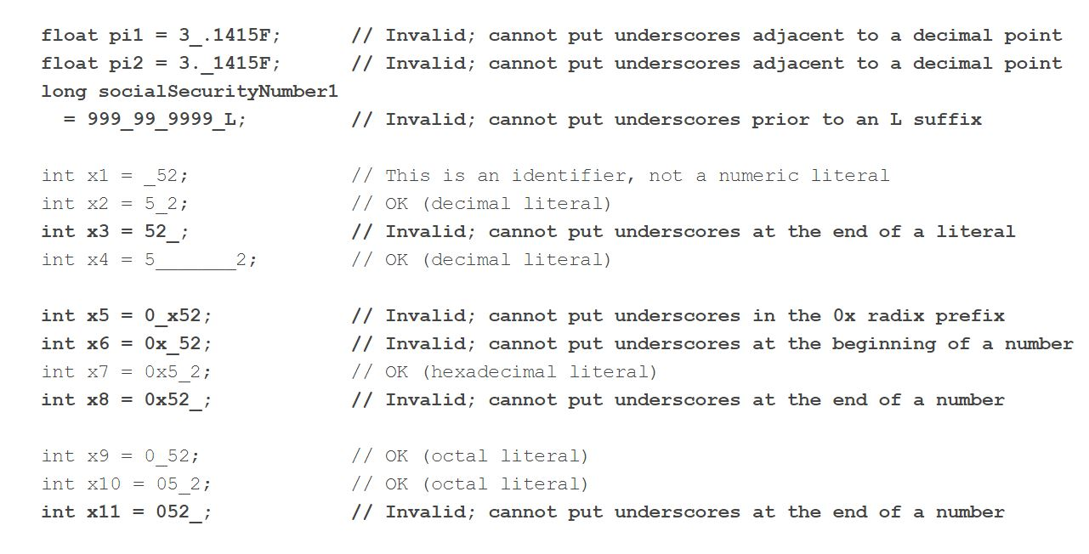

Figure 6 – Invalid underscore using

## Reference types

* A reference type refers to an object (instance of a class).
* References do not hold the value of the object they refer to.
* A reference “points” to an object by storing the memory address where the object is located.

java.util.Date today;

String greeting;

today = new java.util.Date();

- points to a new Date object in memory

greeting = "How are you?";

- points to a new String object.

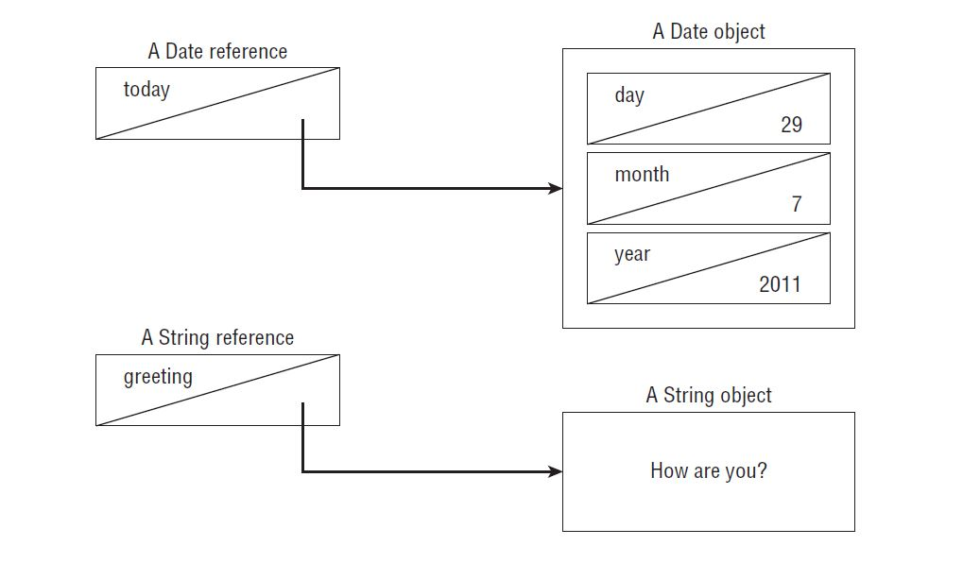

Figure 7 – Reference types

## Differences between primitives and reference types

* Reference types can be assigned null and it’s their default value.
* Primitive types will only give a compiler error if you attempt to assign them null

int value = null; // DOES NOT COMPILE

String s = null;

* Reference types can be used to call methods when they don’t point to null.
* Primitives don’t have methods declared on them.

# Declaring and initializing variables

* We declare variables like this: String a**;** int b;
* Initializing means giving a value to the variable: a=”test”; b=8;
* You can declare multiple variables in the same statement as long as they are all of the same type:

String s3 = "yes", s4 = "no";

* How many are declared and initialized here?

int i1, i2, i3 = 0;

int num, String value; // DOES NOT COMPILE

* Which of the following are legal (valid)?

boolean b1, b2;

String s1 = "1", s2;

double d1, double d2;

int i1; int i2;

int i3; i4;

* Three rules to remember for legal identifiers:
  + The name must begin with a **letter** or the symbol **$** or **_**
  + Subsequent characters may also be numbers.
  + You cannot use the same name as a Java *reserved word*.
* Conventions: - methods and variables names begin with lowercase letter followed by CamelCase.
* Class names begin with uppercase letter followed by CamelCase.

# Operators

**Question**:

1. What is the data types after performing the following operations:
   * int x = 1; long y = 33; 🡪 x*y
   * double x = 39.21; float y = 2.1f; 🡪 x+y
   * short x = 10; short y = 3; 🡪 x/y
   * short x = 14; float y = 13; double z = 30; 🡪 x*y/z
2. Response:
   * A. long.
   * B. Double
   * C. Int
   * D. First, x will automatically be promoted to int solely because it is a short and it is being used in an arithmetic binary operation. The promoted x value will then be automatically promoted to a float so that it can be multiplied with y. The result of x * y will then be automatically promoted to a double, so that it can be divided with z, resulting in a double value.

# If-Then Statement

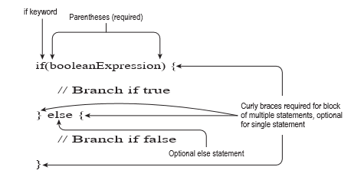

Figure 8 – If Statement

**Ternary operator:**

**booleanExpression ? expression1 : expression2**

# Switch Statement

Switch can be performed on the following data types:

* int and Integer;
* byte and Byte;
* short and Short;
* char and Character;
* String;
* enums;

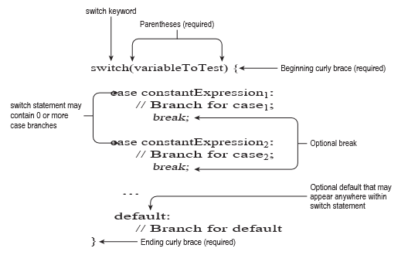

Figure 9 – Switch Statement

# While / Do while

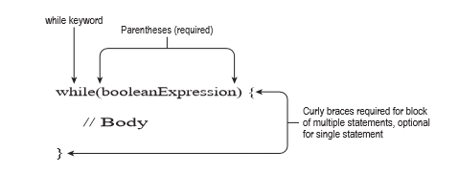 Figure 10 – While Statement

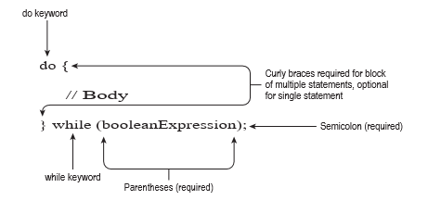

Figure 11 – DoWhile Statement

**Task 4**:

* Print the matrix:

Input:

int[][] matrix = {{5,2,1},{3,9,8},{5,7,3}};

OUTPUT:

521

398

573

# Break / Continue

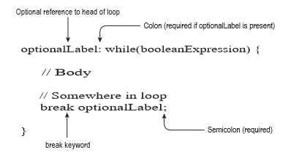

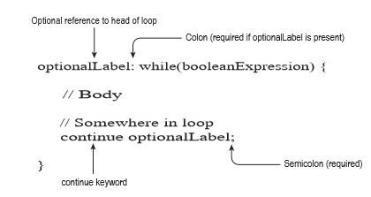

Figure 12 – Break & Continue

# Scanner Class

Scanner is a class in java.util package used for obtaining the input.

**Eample**:

**public class** M_Scanner {  
 **public static void** main(String args[]){  
 *// Declare the object and initialize with  
 // predefined standard input object* Scanner sc = **new** Scanner(System.***in***);  
  
 *// String input* System.***out***.println(**"Insert a name"**);  
 String name = sc.nextLine();  
  
 *// Character input* System.***out***.println(**"Insert gender M/F"**);  
 **char** gender = sc.next().charAt(0);  
  
 *// Numerical data input  
 // byte, short and float can be read  
 // using similar-named functions.* System.***out***.println(**"Insert the age"**);  
 **int** age = sc.nextInt();  
  
 System.***out***.println(**"Insert the mobile number"**);  
 **long** mobileNo = sc.nextLong();  
  
 *// Print the values to check if input was correctly obtained.* System.***out***.println(**"Name: "**+ name);  
 System.***out***.println(**"Gender: "**+ gender);  
 System.***out***.println(**"Age: "** + age);  
 System.***out***.println(**"Mobile Number: "**+ mobileNo);  
 }  
}

**Task 5**:

1. Implement an application that simulates a basic computer that can perform +,-,/,* operations;
   1. User will insert from keyboard the operation that he wants to perform
   2. User insert first number;
   3. User insert second number;
   4. System display the calculation results;
2. Implement an application that calculates the sum of two very big numbers
   1. Read the numbers using Scanner class
   2. Hints:
      1. Use StringBuilder, chartAt;
      2. Check what number is the longest and add padding for the other one?
      3. Use Integer instead of int, Integer.ParseInt;
      4. Use String.valueOf(), String.length();

First number: 1236128736182736128637812

Second number: 123612873618273612863781212323234

Max Length: 33

The sum!!!!!

Final Result: 123612874854402349046517340961046